Financial Analytics

Final Project Report

**Introduction**

In our Financial Analytics final project, we choose **JP Morgan Chase & Co** to do our analysis.

JPMorgan Chase & Co., commonly known as JPMorgan or simply JPM, is a multinational investment bank and financial services company headquartered in New York City.

It is one of the oldest and largest financial institutions in the United States, with roots tracing back to the founding of The Manhattan Company in 1799.

The company has a rich history of mergers and acquisitions, including the merger of Chase Manhattan Corporation and J.P. Morgan & Co. in 2000, forming what is now known as JPMorgan Chase & Co.

**Current Operations**

JP Morgan Chase operates as a multifaceted financial services powerhouse, providing a diverse range of solutions to a global clientele. From investment banking and asset management to retail and commercial banking services, JP Morgan Chase serves millions of individuals, businesses, and institutions worldwide. Its offerings encompass consumer banking products like checking and savings accounts, credit cards, mortgages, and personal loans, as well as commercial banking services such as corporate lending, treasury management, and capital markets solutions. Additionally, JP Morgan Chase's investment banking division facilitates mergers and acquisitions, capital raising, and strategic advisory services for corporations and institutional clients. Moreover, the company's wealth management arm offers personalized investment management, financial planning, and retirement solutions to high-net-worth individuals and families. With a commitment to innovation and client-centricity, JP Morgan Chase continues to expand its operations and adapt its services to meet the evolving needs of its diverse customer base in today's dynamic financial landscape.

**Industrial Competitors**

In the financial services sector, JP Morgan Chase contends with robust competition from key players such as Bank of America, Wells Fargo, Citigroup, Goldman Sachs, and Morgan Stanley. These entities operate across similar markets, offering a comprehensive suite of financial solutions spanning consumer banking, investment banking, asset management, and wealth management. Each competitor brings its own distinctive strengths and strategic approaches to the market, contributing to a dynamic and fiercely competitive landscape. To maintain its competitive edge, JP Morgan Chase consistently innovates and tailors its offerings to meet evolving customer demands. Moreover, the company strategically explores opportunities for collaborations and acquisitions to bolster its market position and ensure continued growth amidst stiff competition.

**Approximate Market Share**

As of recent data, JP Morgan Chase is one of the largest banks in the United States and globally, with a significant market share across various segments of the financial services industry. Its market share varies depending on the specific market and product category, but it consistently ranks among the top competitors in terms of assets, revenue, and customer base. The exact market share figures can fluctuate due to changes in market conditions and competitive dynamics. However, JP Morgan Chase typically maintains a strong position relative to its competitors.

**Financial Ratio Analysis**

**Liquidity Ratios**

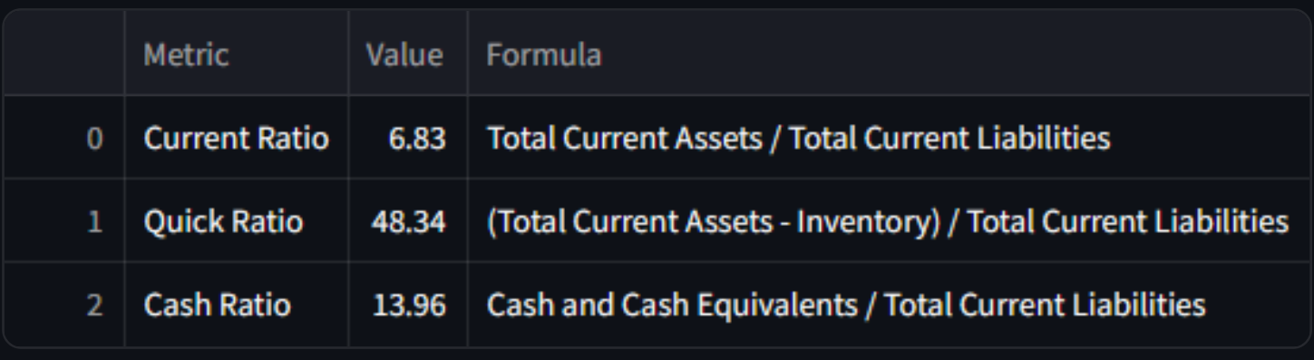

**Current Ratio:** Ratio between 1.5 and 3 is considered healthy.

With a current ratio of 6.83, significantly higher than the healthy range, it suggests that the company holds a substantial amount of current assets relative to its current liabilities. While a high current ratio can be interpreted as a sign of financial strength, excessively high ratios may indicate that the company is not efficiently utilizing its assets.

**Quick Ratio:** Ratio Above 1 or above is good.

A ratio much higher than 1, With a quick ratio of 48.34, significantly higher than the healthy threshold, it suggests an exceptionally high level of liquidity. While having ample liquidity is generally viewed positively, an excessively high quick ratio might indicate that the company is holding an excessive amount of cash or liquid investments that could be better utilized elsewhere.

**Cash Ratio:**

With a cash ratio of 13.96, significantly higher than the norm, it suggests that the company holds an unusually large amount of cash relative to its current liabilities. While a high cash ratio provides a safety net and flexibility in meeting short-term obligations, it may also indicate underutilization of assets or a reluctance to invest in more productive opportunities

**Profitability Ratio**

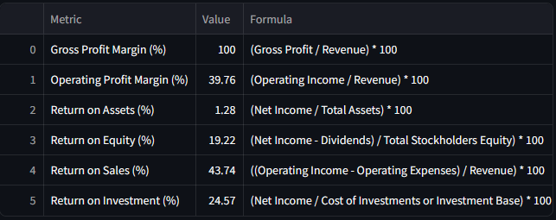

**Gross Profit Margin (100%):** This rate is very high. It suggests that all revenue is gross profit for bank.

**Operating Profit Margin (39.76%):** A operating profit margin of 39.76% implies that for every dollar of revenue generated, the company retains approximately 40 cents as operating profit. This indicates efficient management of operational costs, allowing the company to generate healthy profits from its core business activities

**Return on Assets (1.28%):** A return on assets of 1.28% suggests that the company earns approximately 1.28 cents in net income for every dollar of assets it owns, including buildings, equipment, and investments.

**Return on Equity (19.22%):** A return on equity of 19.22% indicates that investors receive approximately 19.22 cents in net income for every dollar of equity they have invested in the company.

**Return on Sales (43.74%):** A return on sales of 43.74% implies that for every dollar of sales revenue, the company retains approximately 44 cents as net profit.

**Return on Investment (24.57%):** A return on investment of 24.57% suggests that the company earns approximately 24.57 cents in profit for every dollar invested in various initiatives, such as new projects, acquisitions, or capital expenditures.

**Earnings Ratio**

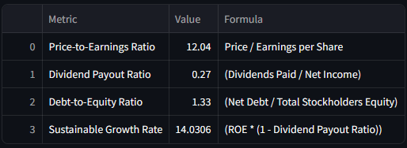

**Price-to-Earnings Ratio (12.04):** The price of the company's stock is 12 times more than what the company earns for each share. This means the stock might be priced just right, not too expensive or too cheap based on its earnings.

**Dividend Payout Ratio (0.27):** A ratio of 0.27 indicates that the company distributes 27% of its profits as dividends to shareholders, while retaining the remaining 73% for reinvestment in the business or other uses.

**Debt-to-Equity Ratio (1.33):** A ratio of 1.33 suggests that for every dollar of equity invested by shareholders, the company has $1.33 in debt. This indicates that the company employs a mix of equity and debt financing to fund its operations and growth initiatives.

**Sustainable Growth Rate (14.0306%):** A sustainable growth rate of 14.0306% suggests that the company can expand its business by approximately 14% annually, assuming it maintains its current dividend payout ratio and capital structure. This indicates that the company is effectively managing its resources and generating sufficient internal funds to support growth without relying on external sources of capital

**Capital Asset Pricing Model – CAPM**

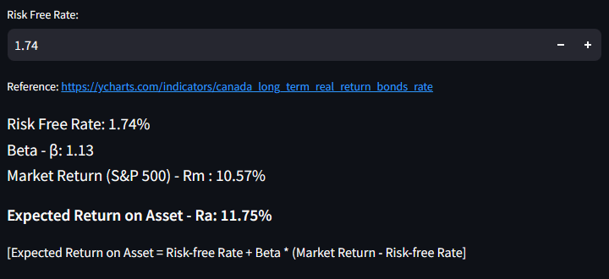

The expected return on the asset (11.75%) is higher than the risk-free rate (1.74%), which is what you would expect for an investment with some risk.

The beta of the asset (1.13) is slightly higher than 1, which means the asset is expected to be slightly more volatile than the market.

It is important to note that this is just a theoretical calculation of the expected return based on CAPM.

**Weighted Average Cost of Capital – WACC**

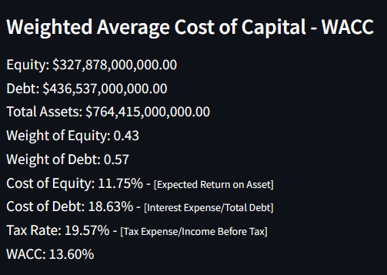

**Weight of Equity (0.43):** A weight of Equity 0.43 suggests that shareholders have a significant stake in the company, exerting considerable ownership and control. This implies that a substantial portion of the company's funding comes from equity sources, reflecting investors' confidence in the business's prospects.

**Weight of Debt (0.57):** A weight of Debt 0.57 suggests a reliance on debt financing to fund the company's operations and growth initiatives. While debt can provide leverage and tax benefits, excessive reliance on debt may increase financial risk and interest expenses, impacting the company's profitability and financial stability.

**Cost of Equity (11.75%):** Investors expect a return of 11.75% on their investment, as estimated by the Capital Asset Pricing Model (CAPM). This rate reflects the opportunity cost of investing in the company's equity compared to alternative investment opportunities with similar risk profiles.

**Cost of Debt (18.63%):** With a cost of debt of 18.63%, the company incurs a relatively high interest expense on its borrowed funds. This suggests that the company's debt carries a significant risk premium, reflecting factors such as credit risk, market conditions, and prevailing interest rates.

**Tax Rate (19.57%):** The tax rate represents the percentage of profits that the company pays in taxes to the government. With a tax rate of 19.57%, the company's profits are subject to taxation at this rate.

WACC (13.60%): The weighted average cost of capital (WACC) represents the average cost of financing for the company, taking into account the cost of equity and the cost of debt weighted by their respective proportions in the capital structure.

Overall, the company’s average cost for the money it uses is 13.60%

**Monte Carlo Simulation**

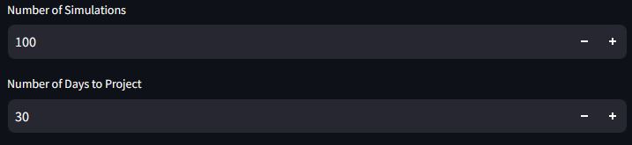

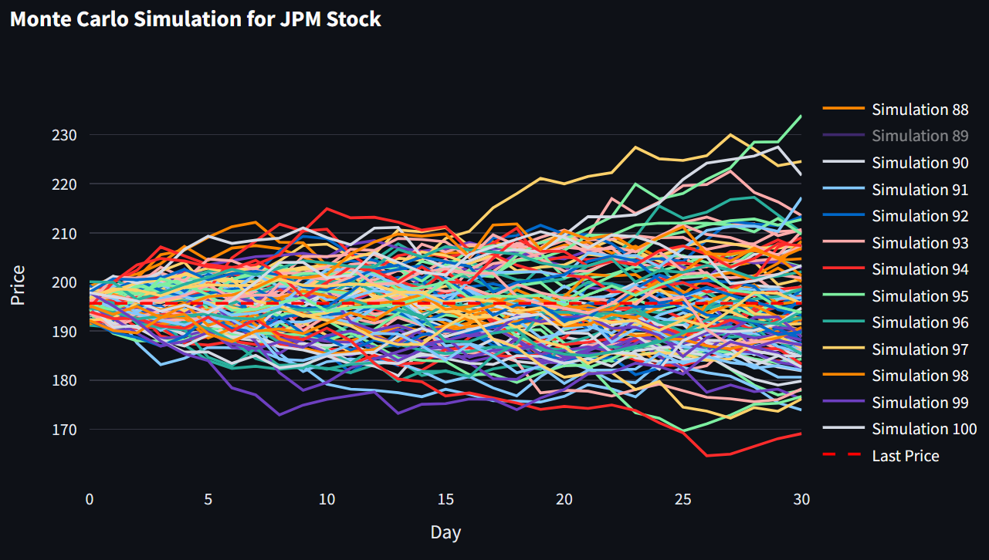

Monte Carlo simulation technique is named after the Monte Carlo Casino in Monaco.

A Monte Carlo simulation is used to model the probability of different outcomes in a process that cannot easily be predicted due to the random variables.

It is a technique used to understand the impact of risk and uncertainty. Monte Carlo simulation predicts outcomes with random variables, helping to understand risk and uncertainty in forecasts.

In finance, the use of Monte Carlo simulations became prominent in the latter part of the 20th century for modeling complex financial instruments, risk management, and portfolio optimization.

**Facebook Prophet**

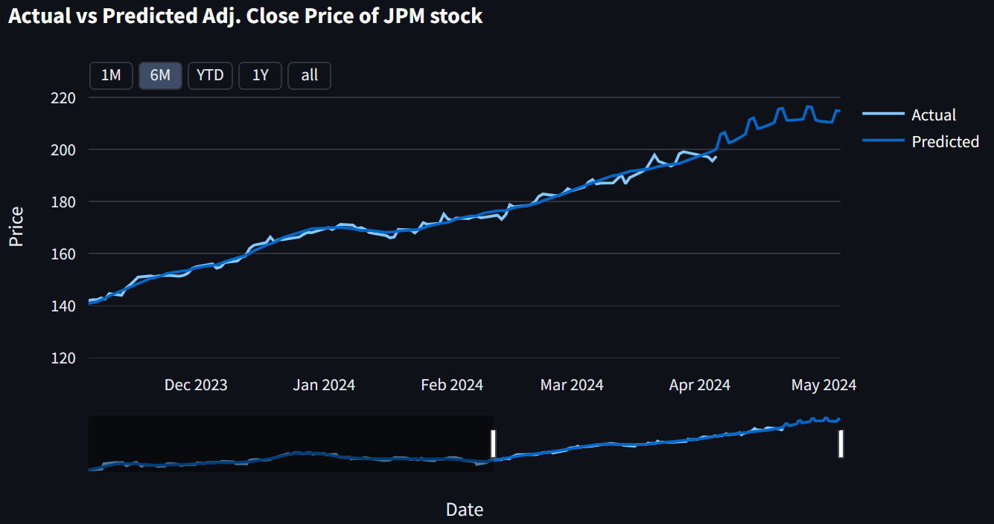

Prophet, developed by Facebook's Core Data Science team, revolutionizes time series forecasting with its accessible interface and robust capabilities. Leveraging a decomposable model encompassing trend, seasonality, and holiday effects, Prophet adeptly manages missing data and outliers while accommodating shifts in data patterns. Its widespread adoption stems from its simplicity, empowering users of varying expertise levels to generate accurate forecasts for a multitude of data types, from business metrics to meteorological trends, thus facilitating informed decision-making across industries.

**Conclusion and Findings**

JPM has a track record of consistent robust earnings and growth, benefiting from its diversified business across various financial sectors. Its operations include retail, commercial, asset management, and investment banking, reducing risk by not relying on a single revenue source.

With a presence in over 100 countries, JPM's global footprint allows it to tap into international markets and mitigate domestic downturns. Significant investments in digital banking and technology position JPM ahead in the evolving financial landscape. JPM's strong capital position enables it to offer steady dividends, appealing to income-seeking investors.

Stock is relatively overvalued (High Price earnings ratio) when compared with peers but future growth prospects, profitability and market leadership in the banking industry make the stock attractive. Existing Investors can hold the stock for long term as a portfolio stock.

Potential new investors can buy the stock whenever the stock price falls during market corrections.

**References**

[Investopedia](https://www.investopedia.com/)

[Financial Modelling Prep API documentation](https://site.financialmodelingprep.com/)

[Yahoo Finance Python Package](https://ca.finance.yahoo.com/)

[Insider Intelligence](https://www.businessinsider.com/research)

[App Economy Insights](https://www.appeconomyinsights.com/p/earnings-visuals-72023)

[Annual Reports of the company](https://www.jpmorganchase.com/content/dam/jpmc/jpmorgan-chase-and-co/investor-relations/documents/annualreport-2022.pdf)